Physiotherapy and recovering from COVID-19
The document provides general information about recovering from COVID-19 at home and should not replace advice of your relevant health care professional.

Staying active
Fatigue and breathlessness are common symptoms of COVID-19, it is important that you stay active within reason. Being active helps to prevent complications from prolonged bed rest including weakness, loss of fitness, worsening of pneumonia or difficulty clearing of secretions, blood clots and pressure sores.

To help you keep active during recovery:
- Maintain some routine: have a shower or a sponge wash at the basin
- Try to dress in your own clothes and save your pyjamas for sleeping.
- Sit out of bed during the day, especially for meals
- Walk around your room at least three times a day or march on the spot

Position changes
Resting in bed for long periods of time can affect your breathing and cause muscle loss.
It is a good idea to try and change positions regularly. Aim for every hour while you are awake, changing between your back, front and sides, or sitting in a chair out of bed. This will help air reach all parts of your lungs and help prevent complications.

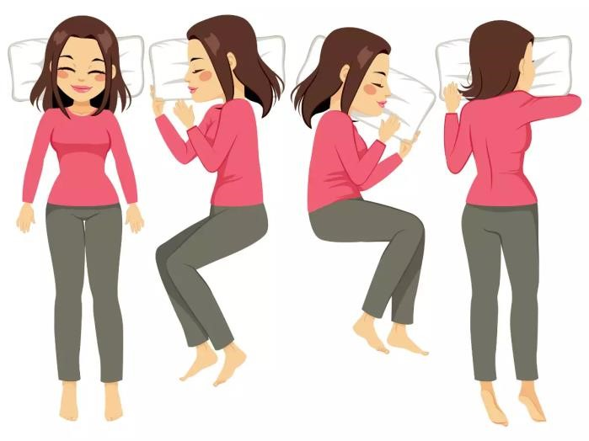

Recovering at home and return to exercise
Gradually returning to exercise is an important part of recovering from COVID-19, particularly in the first 6-8 weeks. Exercise in moderation will help you feel stronger, more energised and less breathless.
A walking program at home is a good way to gradually build up your fitness. You can walk indoors until you are allowed out of quarantine. Aim to be active every day; start with a few minutes and add to that as you feel your symptoms reduce.
Do your activity at a low to moderate intensity. Your breathing and heart rate will be faster, but you should still be able to have a conversation.
You may feel a bit breathless when returning to exercise. However, this should settle when you rest.

Stop exercising if you feel any of the following symptoms:
- chest pain or tightness,
- Dizziness
- blurred vision or excessive shortness of breath.

It is also important to return to doing your regular daily activities. Keep reading to find out more about energy conservation.

If you have any questions or concerns, further advice can be obtained from your GP.

Recovery fatigue
Many people experience ongoing fatigue long after their COVID-19 illness. This can make returning to everyday tasks, exercise and work more difficult. If you are experiencing fatigue that lasts three months after your COVID-19 diagnosis, consider making an appointment with a physiotherapist or your GP.

1. Establish routines
- Plan each day to include only what you can realistically accomplish
- Plan a good mix of activities that you may find more strenuous with those that are light and relaxing activities
- Prioritise tasks

2. Pace yourself
- It's important to take your time using a moderate work pace to help maintain your energy levels
- Divide lengthy activities into short periods. Resting for 10-15 minutes between each activity, instead of doing tasks consecutively
- Rest during activities before you are really tired as you will recover more quickly

3. Sit to perform activities whenever possible

4. Avoid performing overhead tasks as they use up a high level of energy and can make you more breathless.

5. Consider delegating tasks to others in the family, remember to follow any COVID isolation restrictions. Investigate community services available to you. E.g., Meals on wheels or home help. Your local council or GP will be able to provide more information about these services.

Recovery - mental health
Many people also experience ongoing anxiety and depression. Helpful resources include:
- Head to Help for free mental health support by calling 1800 595 212 between 9am and 5pm Monday to Friday
- Care in Mind for free phone counselling in the inner, north and west area of Melbourne by calling 1300 096 269, available 24/7
- Suicide Call Back Service for free counselling by calling 1300 659 467 available 24/7

Additional resources
https://www.safeexerciseathome.org.au/

Safe Exercise at home website

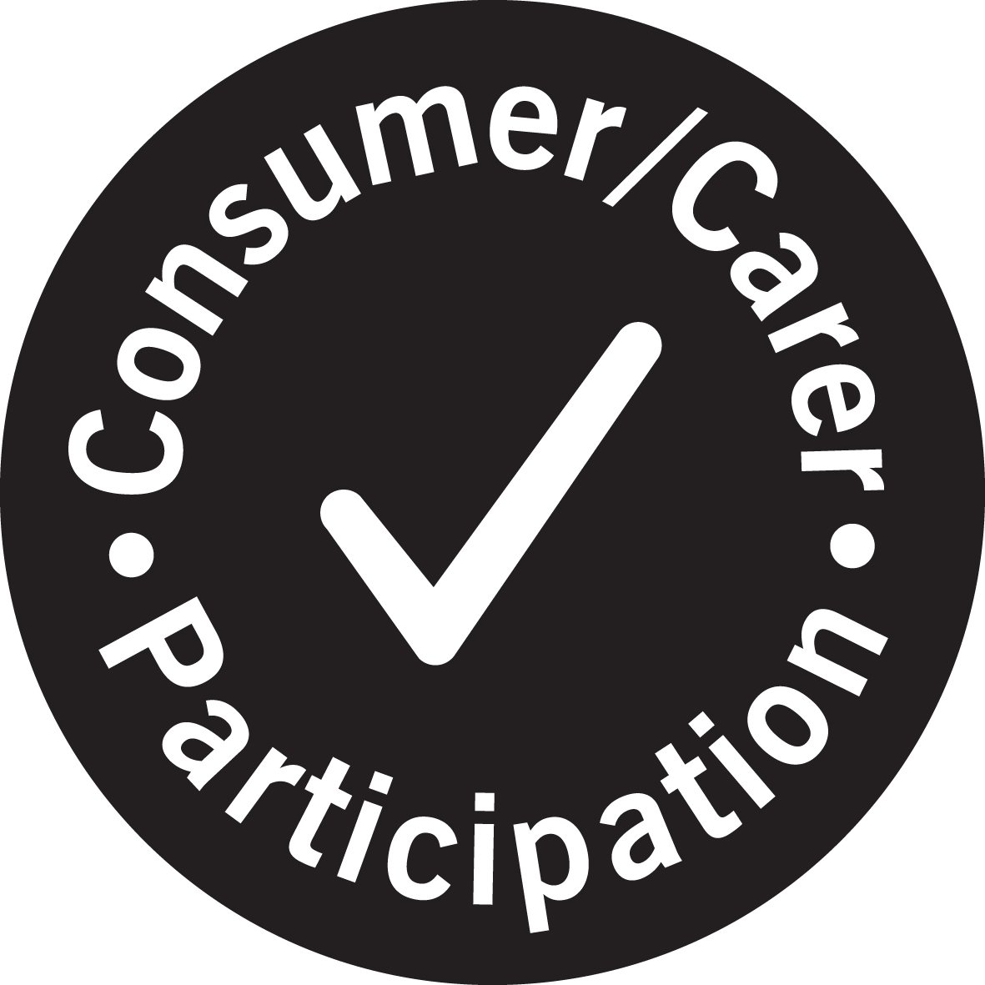

For further information
Department: Physiotherapy Department
Phone: 9496 5000
Date produced: October 2021
Date for review: October 2024

